Emergency plan
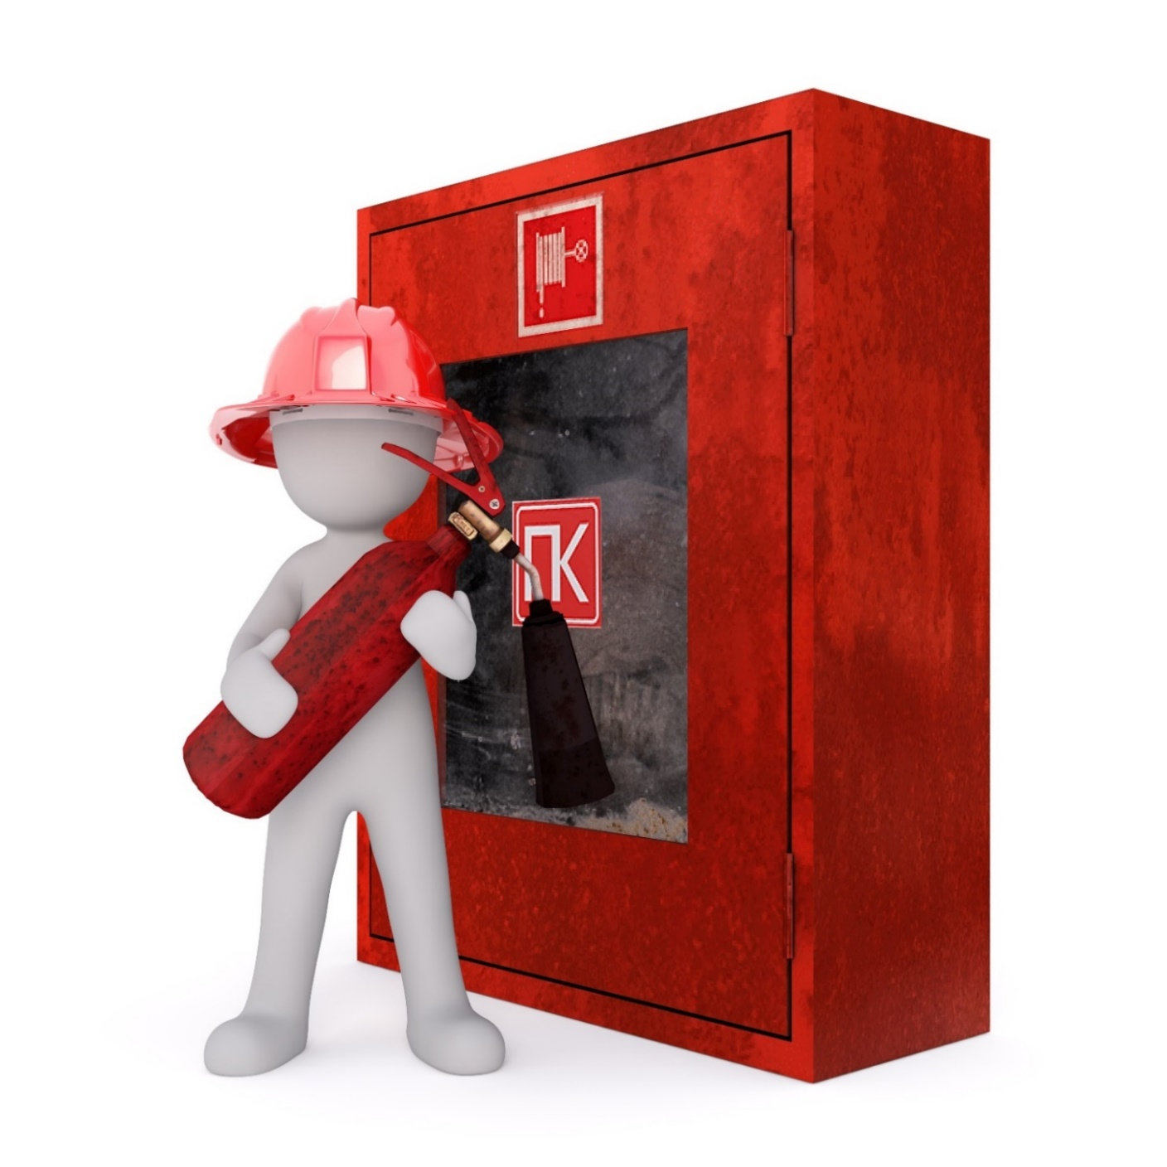
Name
and address
Drafted on xx.xx.202X
Plan inspections and updates: ☐ 202X, ☐ 202X, ☐ 202X, ☐ 202X

CONTENTS
Responsibility for safety in the housing company 3
Housing company board of directors 3
Person/team in charge of safety 3
Property manager 3
Building maintenance company 3
Rescue Department 3
Resident 5
Preventing accidents 5
Reporting safety issues 5
Smoke alarms 5
Closing fire doors 6
Storing items 6
The sweeping of fireplaces 6
Actions to take in hazardous and dangerous situations 6
Housing company accident risks 7
Assessing dangers and risks 7
Fires and arson 9
Accidents and seizures 12
Water damage 15
Power cuts 17
Disruptions to the water supply 19
Disruptions to the heating supply 19
Gas leaks or disruptions to the natural gas distribution 19
Natural disasters and weather phenomena 20
Situations where you need to take cover inside 21
Situations and exceptional conditions where you need to take cover in civil defence shelters 23
Housing company safety arrangements 24
Further information on housing company safety 24

Attachments
XXXXXXX
XXXXXXX

Filling in instructions:
The table of contents is not adjusted automatically. When you are finished, check the table of contents once more to ensure that the titles and page numbers are correct and match the content. Remove this text once you have made the necessary changes.

HOUSING COMPANY SAFETY RESPONSIBILITIES

The housing company’s board of directors is responsible for ensuring that safety regulations are followed
- The housing company board of directors is responsible for:
  - the maintenance of the safety arrangements in the common areas of the building and the outside areas
  - conducting a risk assessment for the housing company and ensuring independent preparedness based on the assessment*
*Independent preparedness means that the housing company is able to operate independently for a certain period of time in various dangerous and hazardous situations without the help of the authorities.
  - drafting and communicating an emergency plan
  - keeping the housing company risk assessment and emergency plan up-to-date
  - …
- The responsibility for overseeing the management of the tasks remains with the housing company’s board of directors, even though some of the tasks mentioned above may in practice be carried out by the property manager, building maintenance company or a separately appointed person in charge of safety.

Contact information
Name of contact person
Phone number
E-mail address
Other contact information
The Person/team in charge of safety aids the housing company’s board of directors
- In this housing company, the tasks of the person/team in charge of safety are as follows:
  - …
  - …
- You can contact the person/team in charge of safety by contacting...

Contact information
Name of contact person
Phone number
E-mail address
Other contact information
The property manager manages the affairs of the housing company in accordance with an agreement
- In this housing company, the tasks of the property manager are as follows:
  - …
  - …
- You can contact the property manager by contacting...

Contact information
Name
Phone number
E-mail address
Other contact information

The building maintenance company is in charge of many practical issues
- In this housing company, the tasks of the building maintenance company are as follows:
  - …
  - …
- You can contact the building maintenance company by contacting...

Contact information
Name
Phone number
E-mail address
Other contact information
The Rescue Department provides advice as well as overseeing and helping in the event of an emergency
EMERGENCY NUMBER 112
1. Make the emergency call yourself, if possible.
2. Provide your exact address and municipality.
3. Answer any questions.
4. Follow instructions.
5. Only end the call when you have been given permission to do so.
6. Guide rescuers to the scene.

Call the Emergency Response Centre again if the situation changes.

Our address is:
Name of street and house number,
Helsinki
- You can contact the on-call fire safety inspector at the Rescue Department to discuss non-urgent matters.
- You must always call the emergency number 112 in the event of an emergency.

Contact information
On-call fire safety inspector
Tel. +358 (09) 310 31203, weekdays from 9.00–11.00 a.m. and 12 noon – 14.00 p.m.

Filling in instructions:
Fill in the tasks and contact information of the different operators. Also ensure that there is a clear understanding of the allocation of tasks between the parties (in commission agreements, for example) and that the parties are aware of their tasks. Remove this text once you have made the necessary changes.
You can download the 112 Suomi application on smartphones. When you place an emergency call through the application, your location is automatically transferred to an Emergency Response Centre worker.
The application can be downloaded free-of-charge onto Android, iOS and HarmonyOS phones.

My responsibilities as a resident
Preventing accidents is more productive than repairing damage
- It is the duty of each resident to strive to prevent dangerous situations and accidents. The housing company has carried out a risk assessment, the results of which are presented on the following pages. Please read them carefully to be better equipped to identify hazards and possible causes of them.
- Be careful and cautious. The emergency plan contains advice that you can heed to decrease the risk of accidents.
Reporting safety issues is the duty of each resident
- The responsibility to report applies to all safety issues you come across and other observation you may make relating to safety in your home.
- Do not assume that someone else is going to report the issue!
- The tasks and contact details of various parties are listed on the previous pages.
You are responsible for smoke alarms
- The acquisition, testing and maintenance of the smoke alarms in your home are your responsibility
- Install at least one smoke alarm on each floor for each 60 square metres of floor area. We recommend that a smoke alarm is installed in each bedroom, in addition to one each in the living room and any other open spaces. Smoke alarms are always installed on the ceiling in a central location.
- Test that your smoke alarm is operational and replace batteries in accordance with the instructions. The Rescue Department recommends testing smoke alarms at least once a month and replacing batteries once a year.
- Replace smoke alarms at least every 10 years, or when the alarm does not function properly.

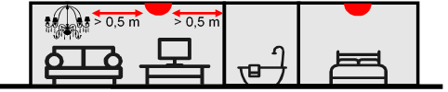
The smoke alarms are connected to the electrical grid, but it is your responsibility to test them
- The smoke alarms in the housing company are connected to the electrical grid. This means that the housing company has acquired and installed the smoke alarms in the flats in advance.
- The building maintenance company is in charge of replacing batteries. Smoke alarms are serviced…
- As a resident, it is your task to test the smoke alarms…
- If you wish, you may also acquire your own battery-operated smoke alarms for your flat. You are responsible for the testing and maintenance of the alarms you have acquired.
Closing fire doors reduces damage
- The following doors are fire doors:
  - …
- Always close fire doors.
*Tip: mark monthly dates for testing smoke alarms in your calendar in advance.
Storing items is only allowed in allocated places
- Stairwells or hallways in the attic or the basement are not intended for storing items.
- Liquefied petroleum gas and other flammable gases or liquids
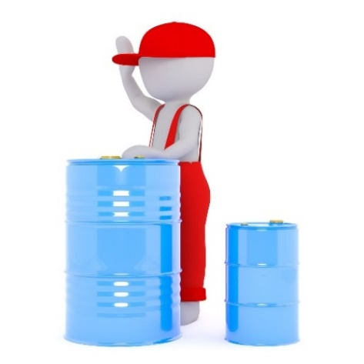
  - may not be stored in storage space allocated for movables (basement storage units)
  - may not be stored in other common areas, such as bicycle shelters or the common room
  - may be stored in your own flat (25 kg of liquefied petroleum gas and 25 litres of flammable liquids). Please note that gas containers must be stored so that they cannot heat up or fall over and be dented (explosion risk).
- The shared shelter for vehicles may only be used for storing vehicles, no other items
- You can use your own garage for the storage of tools and equipment required for vehicle maintenance in addition to your vehicle
  - You may store up to 60 litres of petrol, 200 litres of diesel and 25 kg of liquefied petroleum gas.
  - Extensive repair work or work posing a fire hazard, such as painting or welding, are not permitted in the garage. The garage is also not intended to be used as a storage space or workshop, but instead for the specific purpose of storing your vehicle.
- You may not use your own flat or balcony as a storage space
  - If ignited, a large number of items makes it more difficult to exit the flat and accelerates the spreading of the fire. The structures of the flats are not designed to withstand exceptionally intense burning.
- Do not park your vehicle or leave any items on emergency access roads. All obstacles delay the arrival of help.
  - For example, when moving, there should always be someone near the moving vehicle who is able to move the vehicle immediately.
- Do not leave rubbish outside rubbish containers.
Education and practical training pay off! Training is provided by the following parties:
- the rescue department
- the rescue society (e.g. the asuinkiinteistön turvallisuus (safety of residential buildings) training courses)
- contract fire brigades (e.g. first aid extinguishing training)
- the Finnish Red Cross (first aid training)
- private security companies.
The Sweeping of fireplaces must be carried out once a year, if the fireplaces are in use
- In this housing company, the sweeping of fireplaces is commissioned by…
- The chimney sweep must have a chimney sweep qualification.
- If the fireplace has been out of use for a minimum of three years, sweeping must be commissioned before a fire is lit in the fireplace for the first time.
Acting in a dangerous or hazardous situation is the responsibility of everyone
- Remove the cause of the hazard, if you can do so safely. For example, you can spread sand on a slippery spot in the yard. Report any actions you have taken and any necessary further action.
- Warn others of the danger! Mark the dangerous area or otherwise prevent anyone else from being affected.
- In case of emergency, call the emergency number and undertake those rescue actions that you are capable of.
- You can find more detailed instructions on how to act in different hazardous situations in this emergency plan.

Filling in instructions:
Edit this section by filling in the fields (who, when / how often and how). Also write down any necessary additions and remove any fields that do not apply to your housing company. You can, for example, remove the section concerning chimney sweeping if there are no fireplaces in your housing company. You can also remove the section concerning garages and vehicle shelters, if there aren’t any. For smoke alarms, only keep text that corresponds to the arrangements in your housing company. Remove this text once you have made the necessary changes.

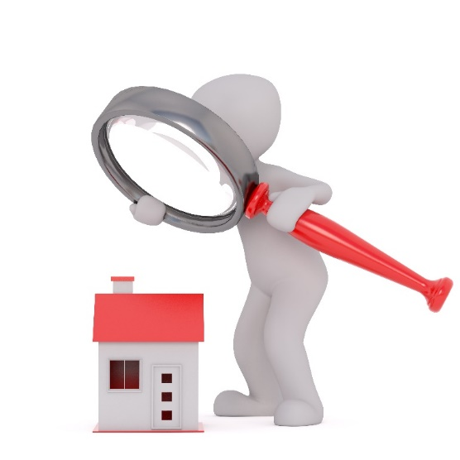
HOUSING COMPANY ACCIDENT RISKS
The assessment of dangers and risks
The housing company risk assessment was carried out on xx.xx.xxxx. The risk assessment was conducted on…
and the following people participated:
- person x
- person x
- …

The risk assessment was updated on
- xx.xx.xxxx; [provide a short description of the changes]
- xx.xx.xxxx; [provide a short description of the changes]

Accident or disruption | Possible cause/source in the home or the housing company | Possible consequences and  effects on everyday life
Fire | - Electrical equipment (faults, connecting multiple extension cords)  - Handling of fire (candles, barbecues, smoking)  - Cooking (when tired or intoxicated, use of cooking fat, cooker hood grease filter dirty)  - Drying clothes on the sauna stove, on top of a radiator or in front of a fireplace  - Ignition of dust accumulated behind household appliances (esp. fridges, washing machines)  - Faulty fireplace or flue  - … | - Property damage  - Fire-damaged flat/space  - If fire compartmentation is not functional, damage occurs elsewhere, as well  - Further damage caused by extinguishing work (water)  - Costs incurred due to repairs  - Personal injuries  - Burns  - Serious injuries  - Death  - Residents must move (at least for the duration of the renovation work)  - The feeling of safety among the residents is disturbed  - …
Arson | - A pram or other flammable materials in the stairwell or by the side of the building’s exterior wall  - Rubbish containers  - Poor lighting or unlocked doors make it easy for unauthorised people to enter  - … | - See previous section  - If there is a fire in the stairwell, the risk of serious injury or death increases, if the residents do not know how to act properly  - …
Accident | - Stumbling, slipping or falling (slippery or uneven ground in the yard, slippery floors in the stairwell, sauna or washing area, items left along routes, a person’s physical condition is also a factor)  - Burns (cooking, sauna stove, fire)  - Accidents involving a knife (cooking)  - Snow and ice falling from the roof  - Falling (playground equipment, roof, ladders, balconies)  - Electric shocks (faulty electrical equipment or wiring, electrical grid in the disconnected neutral state, using electrical equipment in humid conditions)  - Poisonings (plants in the home or in the yard as well as detergents and medicine. Children and pets at risk, in particular)  - … | - Personal injuries  - Anything from minor injuries to death  - Claims for damages from the housing company  - …
Water damage | - Burst pipe (due to poor condition or variations in temperature)  - Seal breaking on household appliances or pipes (esp. washing machines, poor installation work, old seals)  - Leaving the water valve for the washing machine open  - Leaky roof (due to poor condition or a falling tree)  - Clogged or blocked floor drain (neglected cleaning, falling asleep on top of the drain while intoxicated)  - Heavy rain, melting water, floods  - … | - Property damage  - Residents must move (at least for the duration of the renovation work)  - Also a danger of electric shocks  - …
Power cut | - In your own flat: grid overload or faulty device  - More extensive cuts: storm, other fault in the power grid independent of the resident  - … | - Normal everyday life is disturbed  - Water supply and heating are cut off  - The risk of accidents increases in the dark  - If electrical equipment that has a tendency to heat up has been left on, there is a risk of fire once the power comes back on  - ...
Disruption  in the water supply | - Power cut  - Repair work  - Pipe burst  - Contaminated water  - … | - Normal everyday life is disturbed  - Possible health hazards, if the water is contaminated  - …
Disruption  in heat distribution | - Power cut  - Heat exchanger breakdown  - Disruptions in the heating system  - … | - Flat cooling down in winter  - …
Gas leak or disruptions in natural gas distribution | - Gas leak  - … | - Explosion risk  - Health hazards when inhaled in large concentrations  - Flats cooling down in winter during longer fault situations  - …
Natural  disaster or  weather phenomenon | - Thunder, wind and storms  - Snow loads and ice  - Floods  - Heat  - … | - Storm damage (damaged roofing)  - The risk of accidents (items blown away by the wind)  - Risk of water damage (floods, heavy rains)  - Health problems, especially in particularly cold or hot weather  - …
Accidents  where you need to  take cover inside | - Fire in the vicinity causing toxic smoke to enter the area  - Chemical accident causing toxic substances to enter the area  - Other gas hazard  - Radiation accident (e.g. accident at a nuclear power plant)  - Rough weather | - Normal everyday life is disturbed (a home emergency supply kit will alleviate the situation)  - Health problems, if residents are subjected to toxic substances
Exceptional conditions | - State of war or some other serious disruption affecting the operation of the entirety of society | - Serious disruption to society at large
Other special characteristics of the housing company or the area | - …  - … | - …  - …

Filling in instructions:
The above table contains some of the most common causes and consequences of accidents. However, the list is not exhaustive. Risk assessments must always be conducted site-specifically in order to ensure that the special characteristics of each building and its surroundings are taken into account. If your building is not located in a flood risk area, for example, you can remove the section on floods. On the other hand, if the building has a pool, it must be taken into account as a possible source of water damage. Risk assessments can be carried out by organising a safety walk to map any hazards in the housing company. You should organise a shared think tank in connection with the safety walk in order to discuss risks that cannot be directly observed in the surroundings (such as risks related to human behaviour, risk that are not topical at the time of the meeting, etc.).
Remove this text once you have made the necessary changes.

FIRE AND ARSON
What can you as a resident do to prevent fires and arson?
- Ensure electrical devices, wires and chargers are kept in good condition; check the condition of your devices regularly, only use devices for their intended purpose and take faulty devices out of use immediately.
- Place equipment that heats up, such as irons and batteries being charged, sufficiently far away from flammable materials.
- Only use household appliances and chargers when you are present and awake; when you are not there or are asleep you will not be able to detect any faults in the devices.
- Unplug the plugs of devices that do not require constant power, when you are not using the device and especially when you leave for longer periods of time.
- Do not store flammable materials on top of or near the stove. Also prevent devices from switching on inadvertently and prevent children or animals from switching devices on.
- Only burn candles on non-flammable, sturdy surfaces. You must not leave burning candles unattended.
- If you smoke, use an ashtray made out of a non-flammable material.
- Be careful when you cook. You are more likely to forget things when you are tired or intoxicated.
- Do not leave a gas cooker on without supervision and be careful to keep your sleeves far away from the flame.
- Do not dry clothes in the sauna, on top of radiators or near fireplaces.
- Do not leave flammable items in the reach of arsonists along the outside walls of the building or in common areas.
- Make sure your fireplace is kept in working order by having it swept once a year and prevent fire from spreading from the fireplace with the use of protective sheets, grilles and flaps and by ensuring that there are no flammable items in the vicinity of the fireplace. Make sure that any ash you dispose of has completely cooled down.
- Vacuum dust regularly from behind large household appliances, such as refrigerators and washing machines, in particular.
- Clean dust, dirt and grease from your cooker hood regularly.
- Handle liquefied petroleum gas and flammable liquids carefully, and do not store them in your flat unnecessarily.
- Report any fire risks you observe that you cannot eliminate yourself.
- …
What can you as a resident do to prepare for fires?
- Equip your home with smoke alarms, which warn you of dangers and are mandatory in households. Please refer to the My responsibilities as a resident section at the beginning of the guide.
- If your home has a fireplace, you should also equip the flat with a carbon monoxide alarm.
- Be prepared for first-aid extinguishing
  - Equip your kitchen with a fire blanket (at least 120 cm x 180 cm in size, so that it can also be used for extinguishing fires on larger household appliances or people).
  - A 6 kg foam, liquid or dry powder extinguisher is suitable for homes.
  - Store extinguishers in places where they are quick and easy to reach.
  - When cooking, keep the lid of the saucepan or pot at hand to be able to choke any flames using the lid.
- Make sure that it is easy to leave the space in the event of an emergency (and in dark/smoky conditions).
- Always close fire doors.
- Do not park your vehicle or leave any items on emergency access roads.
- Make sure that you know what to do in a fire.
- ….
Check off the sections that you are already doing in your home on the list above. Are there any sections on the list that you should pay more attention to?
What is the housing company doing to prevent fires and arson?
- Ventilation ducts are cleaned every … years. The cleaning is commissioned by…
- The condition of electrical equipment is inspected regularly every … years. The cleaning is commissioned by…
- In order to prevent arson, the housing company…
  - Lighting in outside areas…
  - Rubbish containers are located in…
  - Locks…
- Please observe the following when using the common room…
- Please observe the following when using the shared barbecue…
- The housing company’s LPG bottle and flammable liquids are stored in…
- The storing of items is monitored…
  - Items left along the external walls of the building are removed…
  - Items left in the stairwell or corridors in the basement are removed…
- …

How has the housing company prepared for fires?

- First-aid extinguishing equipment in common areas…
- Smoke alarms in common areas…
- Fire doors are serviced and the tightness of fire compartmentation is checked…
- The usability of rescue routes is maintained…
  - Parking is monitored…
  - Snow is removed in the winter…
- Those who need assistance can be located quickly because
  - the house number is illuminated when it is dark and is clearly visible from the street
  - map of the area…
  - stairwells are marked…
  - floors are numbered…
  - the contact details for the building maintenance company are posted near the front door to the stairwell
- The route to the main switchboard and the main water and gas shut-off valves is clearly marked with stickers starting from the exterior walls of the building. The routes are monitored for accessibility…
- The storage locations of gas bottles and other dangerous substances are marked clearly to ensure the occupational safety of firefighters.
- The building has gravitational/automatic smoke ventilation, the condition of which is maintained…
- …
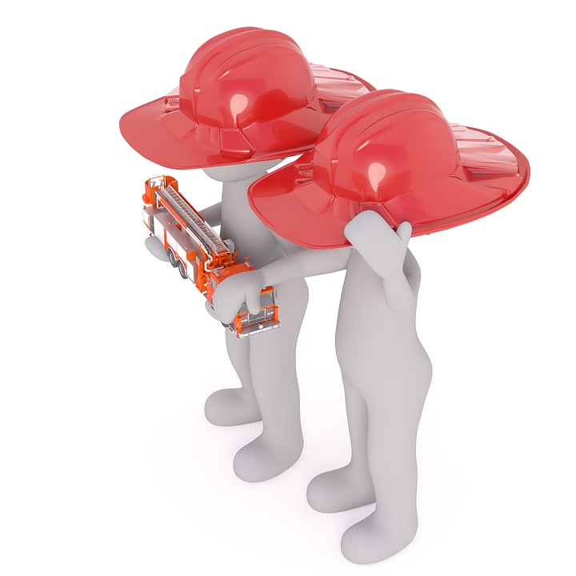
Filling in instructions:
Complete the sections by specifying how, by whom and how often the operation in question is performed. Complete the list when necessary and remove any sections that do not pertain to your housing company (e.g. sections concerning rescue routes can and should be removed if the building does not have any rescue routes).
Remove this text once you have made the necessary changes.

WHAT TO DO IN THE EVENT OF A FIRE
Fire in your flat
- Warn everyone in the flat.
- Extinguish the fire if you are able to do so safely. Do not inhale smoke.
- Leave the flat quickly. You can usually leave the flat safely within 2–3 minutes of the fire starting. If there is smoke in the flat, crawl out or get on all fours to get out.
- Close the doors behind you as you move into a safe place (outside the building). Do not use the lift! If you encounter anyone on the way out, warn them of the fire and tell them not to go into the stairwell.
- Call the emergency number 112 once you are in a safe place.
- Guide rescuers to the scene.
Fire in your neighbour’s flat or the stairwell
- Stay in your own flat: do not enter a smoky stairwell!
- Call the emergency number 112.
- Your flat is a fire compartment and it is designed to keep smoke and fire out. If smoke starts to enter the flat, however, seal any gaps using moist towels, for example.
- Wait for help on the balcony or by an open window. Signal to rescuers by waving your hands or shouting.
The smoke alarm sounds in your flat but you cannot see smoke or any other cause for the alarm

- Individual beeps far apart from each other usually mean that the battery is running out. Replace the battery.
- If the smoke alarm sounds continuously and you cannot detect any signs of fire or other reasons for the alarm (such as vapour or dust), you should replace the alarm. Vacuuming dust off the alarm may help in some cases.
The smoke alarm sounds in your neighbour’s flat, the stairwell or elsewhere in common areas
- Try to determine the cause of the alarm
  - If the alarm goes off next door, ring your neighbour’s doorbell or knock on their door.
  - If the alarm is sounding in a space that you cannot enter to check, call the emergency number 112.
  - If you detect smoke or any other signs of a fire, immediately leave to go to a safe place and call 112. Please note that the nearest safe place may be your own flat. Do not walk through smoke!
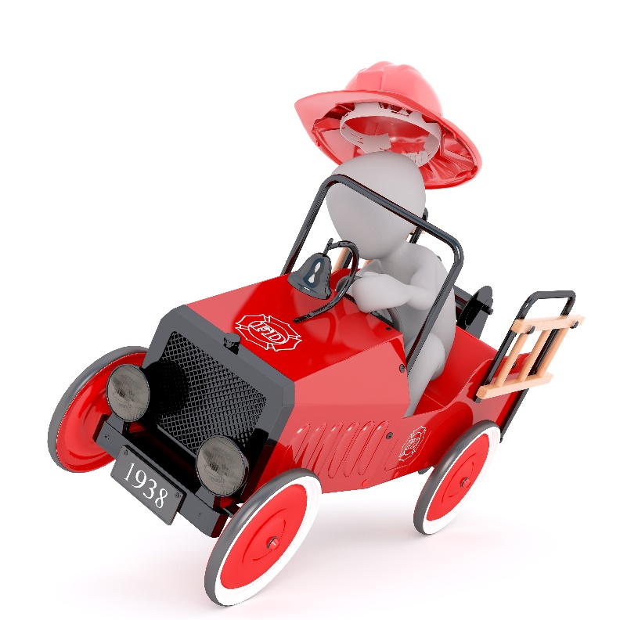
- If it is a false alarm, try to silence it. You must always be sure of the cause of the alarm before silencing it
  - If the alarm that is sounding is located in common areas, call the building maintenance company and report the false alarm, so that the condition of the alarm can be inspected.
  - A smoke alarm that causes false alarms must usually be replaced.
Smoke is extremely toxic and kills quickly!
ACCIDENTS AND SUDDEN ILLNESSES
What can you as a resident do to prevent accidents?
- Use sturdy shoes with good grip when it is slippery outside, consider anti-skid studs.
- If the yard is very slippery, sand it. Sand for sanding is available in… Pease report the hazard to…
- Warn others of any hazards you detect. Equipment for warning others is available at…
- Dry your shoes carefully when you enter the building and clean any puddles on floors immediately.
- Prevent burns by using oven mitts when handling hot cookware or cooking trays and be careful around the sauna stove.
- Be careful when using knives or other sharp objects.
- Use a sturdy ladder if you need to climb.
- Avoid tripping by keeping routes clear and switch on any lights in order to be able to see any obstacles in your way.
- Never use faulty electrical equipment, because it poses a risk of an electric shock. Also remember to never mix water and electricity! Leave any household electrical work to the professionals.
- Poisonings; keep medical substances, detergents and toxic plants away from children and pets.
- Leave enough time for moving around and other activities. Accidents are more likely to happen when you are in a hurry.
- Ask for help with tasks that pose an elevated risk of an accident.
- Report any accident risks you observe that you cannot eliminate yourself.
- …
What can you as a resident do to prepare for accidents and sudden bouts of illnesses?
- Have an emergency kit at home. Ensure that you always have a sufficient amount of personal medication at home.
Nearly 80% of accidents occur at home or in leisure time. More information on domestic accidents, their prevention and preparing for them can be found on the www.kotitapaturma.fi website (in Finnish), amongst others.
- Please ensure that ambulance access routes to doors are as clear as possible.
- Learn the correct first aid for different situations and revise your skills regularly.
- …

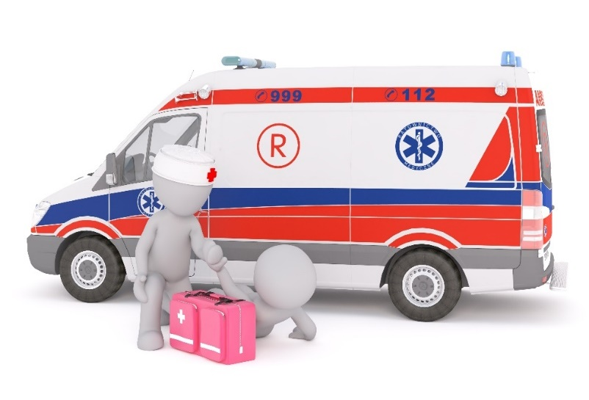
What measures should the housing company undertake to prevent accidents?
- Sanding outside areas…
- Lighting…
- Combatting slipperiness in the stairwell…
- Combatting slipperiness in common sauna areas, wash rooms and laundry rooms…
- Removing snow and ice from the roof…
- Preventing unauthorised climbing onto the roof and other elevated places…
- Preventing electrocution…
- The safety of the play area in the yard is ensured by…
- Ladders for the use of residents…
- Storage of toxic detergents…
- Toxic plants in the yard…
- …
How has the housing company prepared for accidents and sudden bouts of illness?
- First aid equipment for general use…
- Ambulance guides and routes…
- …
WHAT TO DO IN THE EVENT OF AN ACCIDENT OR SUDDEN BOUT OF ILLNESS
Try to determine what has happened. Assess the situation in terms of the need for professional help. If you are unsure, always call the emergency number 112 and follow the instructions given by the Emergency Response Centre. The Telephone Health Service at +358 (0)9 310 10023 for urgent, or non-urgent, round-the-clock guidance in matters related to health is intended for residents of Helsinki.

Start first aid:
- stroke help the person to a resting position, call 112 and monitor the person’s condition while you wait
- asthma attack help the person in taking their medication and help them to a position where it is easier to breathe
- fall in the blood sugar level of a diabetic give the person glucose tablets or something sugary to eat or drink, if the person is conscious. An unconscious person must be placed in the recovery position while waiting for help
- lifeless resuscitation (see diagram on the following page)
- convulsions, epileptic seizure do not try to prevent the convulsions, but prevent the person from getting hurt. Place the person in the recovery position after the convulsions stop and check their breathing
- fracture support the fracture into a position that is as painless as possible so that it cannot move and help the person seek medical attention
- poisoning call the Poison Information Centre (tel. +358 (0)9 471 977). Prevent the substance from being absorbed by administering activated charcoal (do not induce vomiting), rinse the eye or skin with water or help the person breathe fresh air, if the toxic substance has been inhaled.
- sprain or pull apply pressure to the injured section and cool for 15–20 minutes. Bandage tightly
- burn cool with lukewarm water for approximately 10 minutes
- unconscious recovery position (see the diagram on the following page)
- bleeding wound stop the bleeding, rinse the wound with running water and close with medical tape
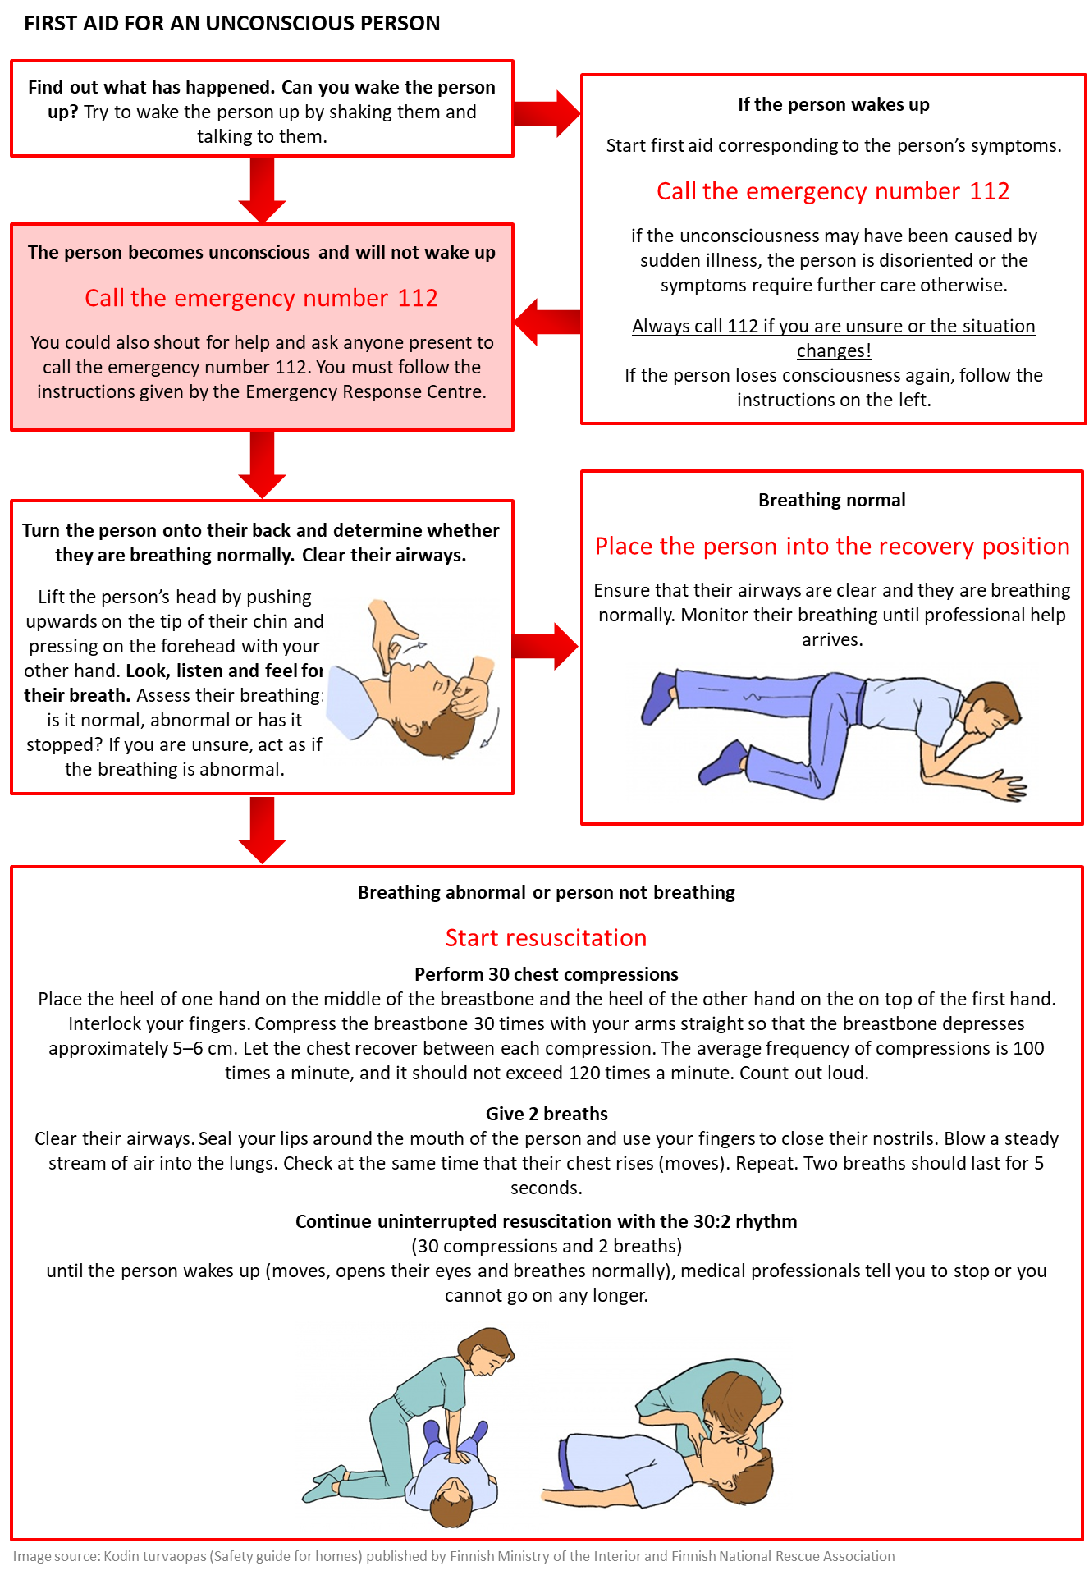
You can practice the correct rhythm for resuscitation with the help of the Bee Gees’ song Stayin' Alive – the tempo of the song is the correct 103 beats per second suitable for resuscitation.

WATER DAMAGE
What can you as a resident do to prevent water damage?

- Check the washing machine connections regularly
- Close the taps after every use
- Only use washing machines when you are present and awake; when you are not there or are asleep you will not be able to detect any faults in the devices
- Leave washing machine installations to the professionals
- Clean floor drains regularly
- Do not take a shower when you are intoxicated
- Immediately report any leaks you detect
What can you as a resident do to prepare for water damage?
- Have a leak tray installed under the dishwasher
- Think of what equipment you may need to manage and dry any leaking water
- Determine where the water seals in your home are located and how to cut power to your flat
- Do not store your belongings at floor level at home or in storage areas
What measures is the housing company undertaking to prevent water damage?
- The machines and devices in the laundry room are serviced…
- The condition of the roof is monitored…
- Water troughs are cleaned…
- The condition of the piping is monitored…
- The pipes are prevented from freezing by…

How has the housing company prepared for water damage?
- Drying equipment…

Filling in instructions:
Complete the sections by specifying how, by whom and how often the operation in question is performed. Complete the list when necessary and remove any sections that do not pertain to your housing company (e.g. sections concerning rescue routes can and should be removed if the building does not have any rescue routes).
Remove this text once you have made the necessary changes.

WHAT TO DO IN CASE OF WATER DAMAGE

- Be mindful of the danger of electric shocks! Cut power to the device and area where the leak is, if possible. You can cut power by…
- Stop the leak
  - You can cut the flat-specific water supply by…
  - You can cut the water supply to the entire stairwell/building from the main water shut-off valve, which is located in...
- Report the damage…
- If the leak is sizable or continues extensively, call the emergency number 112

We recommend that you add an image of the main electricity shut-off valve here
We recommend that you add an image of the main water shut-off valve here

Filling in instructions:
Describe how you can cut off both the water and electricity supply to each flat and the entire building. Remove this text once you have made the necessary changes.

POWER CUTS
What can you as a resident do to prevent power cuts?
- Ensure that the plugs and wires of your electrical devices are intact.

- If you use extension cords, avoid overloading them (lots of devices connected at once).
- Do not connect extension cords to each other.
- Report any risks you observe that you cannot eliminate yourself.
- …
What can you as a resident do to prepare for power cuts?
- Equip your home with
  - a flashlight
  - replacement batteries
  - a battery-operated radio
  - an emergency power supply for your mobile telephone, stored charged
  - replacement fuses
  - firewood (if you have a fireplace or wood-heated stove) and matches.
What measures should the housing company undertake to prevent power cuts?
- Maintenance of electric equipment…
- …
How has the housing company prepared for power cuts?
- The housing company is equipped with…
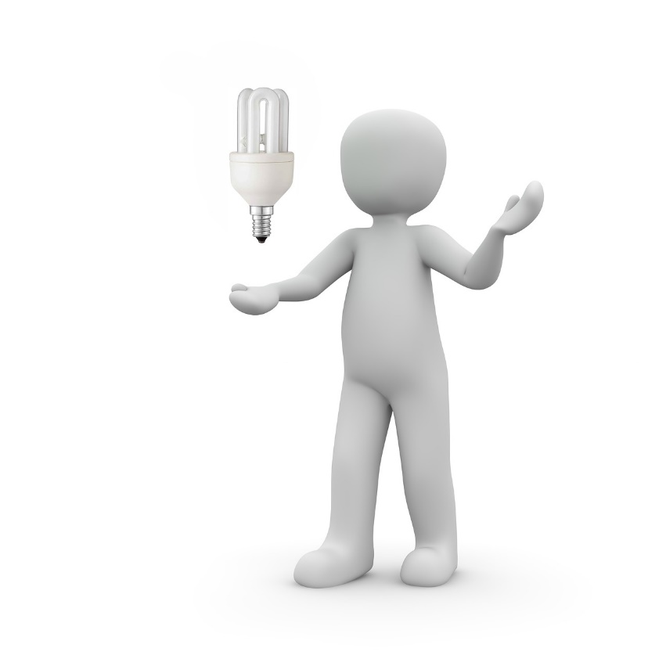
- …

WHAT TO DO IN CASE OF A POWER CUT
- Switch household appliances off.
- Determine the extent of the power cut and act accordingly. Check if your neighbour’s lights are on: if the neighbour’s power is also off, the blackout may be more extensive than just in your flat.
- Avoid using candles for light due to the fire hazard they pose. If you do use candles, however, only burn them on non-flammable, sturdy surfaces. You must not leave burning candles unattended.
If there is a blackout in your flat
We recommend that you add an image of the distribution board and fuses in a flat here
- Check the fuse panel to see if a fuse has blown. If a fuse has blown, replace it or flip the automatic fuse.
- Switch off all electrical equipment that you suspect may be faulty and cause fuses to blow.
If there is a more extensive blackout
- Wait for the power to come back on.
  - You do not have to report the blackout separately. The electricity company is automatically notified of faults in their grid.
  - You should, however, report any damage to power lines, such as trees falling on top of power lines. Due to danger of electrocution, you should never touch the power lines or anything that touches the power lines.
- If you detect any abnormalities in your electric equipment or the lights after the power cut, the electric grid may be in the so-called disconnected neutral state. In this case you should cut the power at the master switch (e.g. while wearing leather gloves and avoiding contact with the electric board) and report the issue to the electricity company.
If the power cut is prolonged
- Please note that power cuts also affect water and heat supplies.
- Do not open the refrigerator or freezer unnecessarily.
- Extensive power cuts also affect the operation of stores and public transport, for example.
The Pahasti poikki – Näin selviät pitkästä sähkökatkosta (Persistent power cut) guide for extended power cuts published by the Ministry of Defence (in Finnish) specifies the effects of long-term power cuts in more detail. The guide is available online (in Finnish) (https://www.defmin.fi/files/1275/Pahasti_poikki_nettiversio.pdf)

DISRUPTIONS TO THE WATER SUPPLY
What can you as a resident do to prepare for disruptions to the water supply?
- Keep bottled water in your home.
- If you know that water supply is going to be cut off, set aside water in a pot or some other receptacle.
How has the housing company prepared for disruptions to the water supply?
- In case of disruptions in water supply, the housing company is equipped with…
WHAT TO DO IN THE EVENT OF DISRUPTIONS TO THE WATER SUPPLY

- If water is supplied despite a power cut, only use water for necessary purposes. If the break in supply lasts for more than one hour, set aside drinking water in a clean covered receptacle.
- Keep bottled water in your home.
- If the break is prolonged, the authorities will start to distribute water. Monitor communications.

DISRUPTIONS TO THE HEATING SUPPLY
WHAT TO DO IN THE EVENT OF DISRUPTIONS TO THE HEATING SUPPLY
In the winter
- Close the windows and keep the front door shut. Also close doors leading to hallways, draught lobbys and the entrance hall.
- Block any cracks in windows and doors with pieces of cloth.
- Stop ventilation and block fresh air ventilators (the round ventilators on walls and ventilators in window frames).
- If your home has a fireplace or wood-heated oven, light it.
- If the disruption to the heating supply continues, move your bed to the warmest spot in your home.

GAS LEAK OR DISRUPTION TO NATURAL GAS DISTRIBUTION
WHAT TO DO IN THE EVENT OF DISRUPTIONS TO GAS DISTRIBUTION
- In the event of a gas leak, try to prevent the gas from igniting.
  - Close the gas shut-off valve. The shut-off valve is located in…
  - Remove any sources of ignition or sparks.
  - Try to ventilate the area.
  - Instruct people to leave the area.
  - Call the emergency number 112.
- Report disruptions to the distribution by calling +358 (0)800 122 552

NATURAL DISASTERS AND WEATHER PHENOMENA
What can you as a resident do to prepare for natural disasters and weather phenomena?
- Read the instructions regarding taking cover indoors and power cuts.
- Do not leave any items that may be blown away by heavy winds out in the yard or on the balcony.
How has the housing company prepared for natural disasters and weather phenomena?
- The building is protected from lightning…
- Snow loads and ice on roofs…
- To prevent damage caused by floods, the housing company is equipped with…
WHAT TO DO IN THE EVENT OF NATURAL DISASTERS AND WEATHER PHENOMENA
- Take cover indoors (instructions below).
- Report any storm damage you observe.
  - Please report any torn roof structures or trees that have fallen or are in danger of falling on top of buildings or roads by calling 112.
  - Report any trees that have fallen on top of power lines to the electricity company. Do not touch the power lines or anything that touches the power lines!
During a thunderstorm
- Avoid using electrical equipment in the vicinity of fireplaces and water pipes.
- If outside, take cover inside a vehicle. You should, however, avoid riding a bicycle or motorcycle.
- Do not use an umbrella or take cover under trees. Also avoid wide open spaces.
- If you are on a boat or otherwise on the water, try to come ashore as soon as possible. Also avoid the shoreline.
- If you detect any abnormalities in your electric equipment or the lights after lightning has struck the building, the electric grid may be in the so-called disconnected neutral state. In this case you should cut the power at the master switch (e.g. while wearing leather gloves and avoiding contact with the electric board) and report the issue to the electricity company.
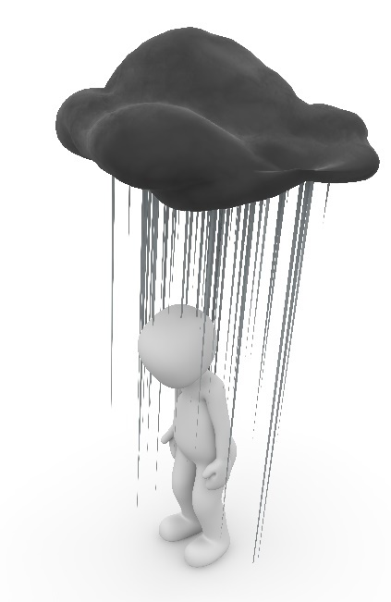
When there is a flood risk
- Do not allow children to play in flood water, because it is often contaminated
- Be careful when moving around, because flood water may have dislocated manhole covers and moved obstacles.

SITUATIONS WHERE YOU MUST TAKE COVER INDOORS

The need to take cover indoors may be signalled with an emergency warning or the public warning signal:
Emergency warning
Emergency warnings are broadcast on all radio channels and shown on teletext page 112 on YLE and MTV3, as well as in the form of a text running across the top of the television screen. The emergency warning describes the danger and provides information on what to do. The public warning signal is always accompanied by an emergency warning.
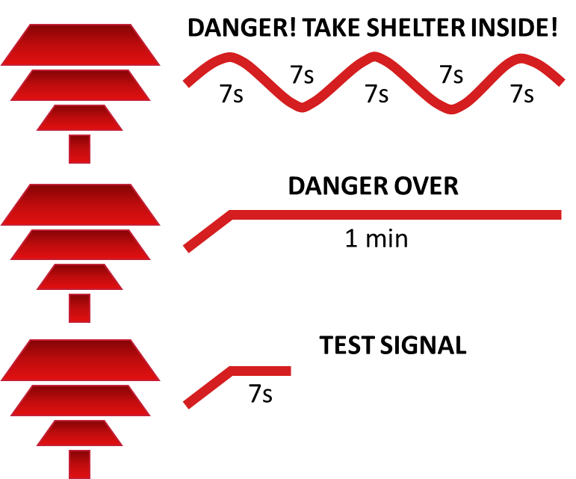
Public warning signal
Immediate danger threatening the population is announced using public warning sirens.
- The public warning signal is a continuous, minute-long undulating sound signal, which is repeated several times, if necessary.
- The all-clear signal is an even one-minute sound signal.
- The siren test alarm is a continuous, even sound that lasts for 7 seconds. In Helsinki, the alarm is tested at 12 noon on the first Monday of each month with the exception of public holidays.

_______________________________________________________________________________________
What can you as a resident do to prepare for situations where you must take cover indoors?
- Get a home emergency supply kit*; recommended home emergency kits have enough of the following supplies for at least three days
  - water and provisions
  - necessary household items
  - personal medication.
- Acquire equipment and tools that you can use to seal your flat, if necessary (duct tape) and protect your provisions from radiation, if necessary (air-tight plastic containers).
How has the housing company prepared for taking cover indoors?
- The emergency ventilation stop system is maintained by…
- The housing company is equipped with the following devices and equipment:
  - XXXX
  - XXXX

*Home emergency supply kits are used to ensure that people can go on with their everyday lives even if normal services are suspended for a while. Situations that require the use of the home emergency supply kit include cases of illness – a person’s own or a family member’s, disruptions in shops and situations that require people to take cover in public shelters, in addition to the need to take cover indoors.

INSTRUCTIONS ON TAKING COVER INDOORS
- Go inside and instruct other residents to do so as well
We recommend that you add an image of the emergency ventilation stop button or the flat-specific ventilation stopping mechanism here
- Stop the ventilation and seal the building
  - In your home: close and seal doors, windows and ventilation openings with duct tape. You can switch off ventilation in your flat by…
  - You can switch off the ventilation in the entire building by…
- Listen to the radio for instructions and follow them.
- Avoid using the telephone.
- Do not exit without being instructed to do so by authorities.
In the event of a gas leak
- You will be best protected on the upper floors of the building. Do not go into the basement.
- Breathe through a moist, loose cloth, if you can smell gas.
- If you are outside, and cannot take cover inside
  - try to get away from the gas into the side wind, try to reach higher ground, avoid low-lying places.
  - avoid getting out of breath and cover your breathing, eyes and skin with a moist cloth.
In the event of radiation
- You will be best protected in the basement or the middle floors of the building.
- Take iodine tablets* only after being instructed to do so by the authorities.
- Cover your provisions to protect them from dust and preserve drinking water in covered receptacles.
- If you must go outside, use a respirator or a protective suit (waterproof clothing).
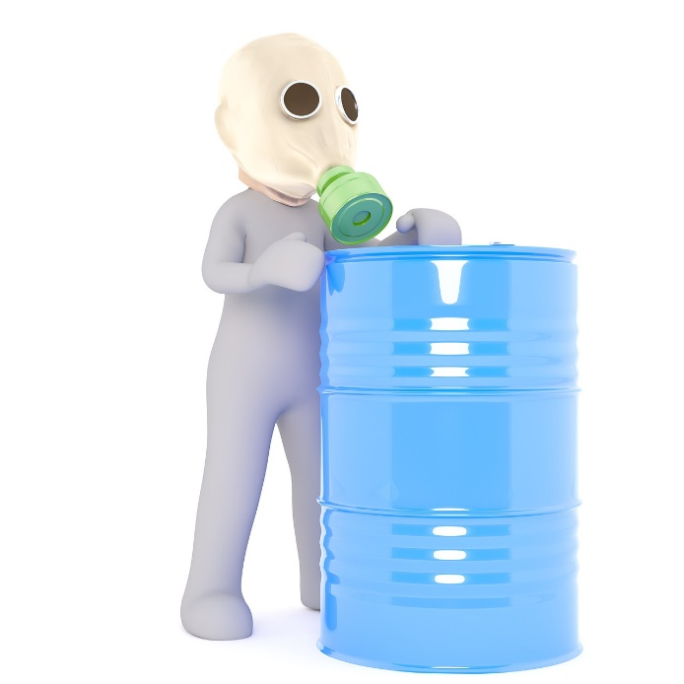
If taking cover indoors is not sufficient, the authorities may tell the residents to evacuate the danger zone. Follow any instructions given. Going outside may require you to protect your eyes and respiratory system and wear a tightly sealed suit (e.g. waterproof clothing).
*Iodine tablets are used to prevent radioactive iodine from collecting in the thyroid gland. Iodine tablets must be ingested at the right time in order to ensure the best possible protective effect. That is why the tablets must only be taken when prompted to do so by the authorities. The tablets are especially important for children and pregnant women.

SITUATIONS AND EXCEPTIONAL CONDITIONS WHERE YOU NEED TO TAKE COVER IN CIVIL DEFENCE SHELTERS

- Civil defence shelters are primarily intended for protection against the use of military force, because civil defence shelters protect people from explosions and shrapnel, cave-ins, pressure waves, chemical weapons and radiation.
- You should take cover in the civil defence shelter when instructed to do so by the authorities. Under normal conditions, civil defence shelters must be maintained so that they can be commissioned in 72 hours.
- In practice, taking cover in a civil defence shelter is only ever as the result of exceptional conditions. Exceptional conditions refer to state of war, for example (a more specific definition is available in the Emergency Powers Act).
The civil defence shelter allocated for the residents is…
Rescue authorities will provide further information on the shelter under exceptional conditions, if necessary.
_______________________________________________________________________________________
What can you as a resident do to prepare for situations and exceptional conditions where you need to take cover in civil defence shelters?
- Get a home emergency supply kit; recommended home emergency kits have enough of the following supplies for at least three days
  - water and provisions
  - necessary household items
  - personal medication.
How has the housing company prepared for situations and exceptional conditions where you need to take cover in civil defence shelters?
- Civil defence shelter maintenance…
  - Testing and maintenance of ventilation equipment...
  - Tightness testing every 10 years…
  - Materials in the civil defence shelter...
- The commissioning of the civil defence shelter in 72 hours is enabled by…
  - Civil defence shelter manager…
  - Commissioning plan…

Housing company safety arrangements

Housing company safety arrangements...

Filling in instructions:
As you have filled in the plan, you have described at least the main sections of the safety arrangements of your housing company. You can make additions to this here, provide a summary of the safety arrangements or attach an image or images that depict the arrangements. We recommend adding an image of the building and its outside areas and marking the following on the image
- central unit of any smoke alarm system present
- manual triggering device for the smoke ventilation
- emergencyventilation stop arrangements
- rescue route and the locations for the hydraulic platform
- main switchboard
- main water shut-off valve
- main gas shut-off valve
- location of first-aid extinguishing equipment in common areas
- shared first aid kit
- civil defence shelter.
Remove this text once you have made the necessary changes.

FURTHER INFORMATION ON HOUSING COMPANY SAFETY IS AVAILABLE AS FOLLOWS

In this housing company, safety issues are communicated by…

Filling in instructions:
Write a description of how safety issues are communicated in your housing company. Communications must be regular. Describe at least how the information in the emergency plan is provided to the residents, where the plan can be accessed, how the plan will be updated and how the updates will be communicated. In addition, the housing company may organise shared training sessions, safety walks and practical training such as first aid extinguishing training.

